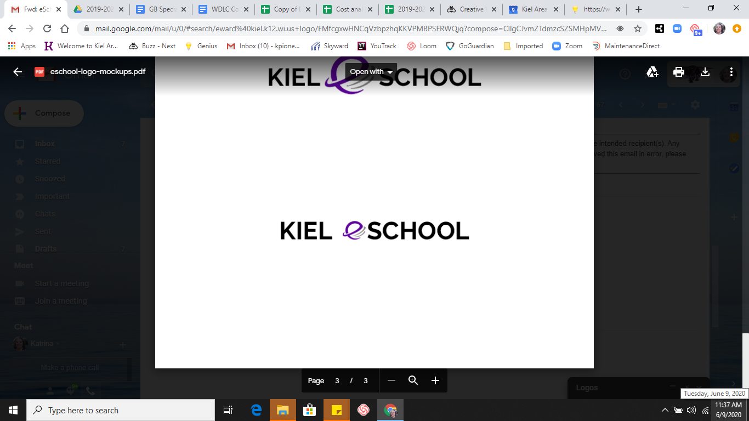

Permission to Release Records

I hereby authorize Kiel eSchool to release official transcripts to ANY INSTITUTIONS AUTHORIZED BY STUDENT OR PARENT as noted on the “Current Student Transcript Request” Form.

- Post Secondary Institutions Parent Initials _____ Student Initials _____
- Military Parent Initials _____ Student Initials _____
- Employer Parent Initials _____ Student Initials _____
- Scholarship Applications Parent Initials _____ Student Initials _____

Pupil Records Of: ________________________________________________

Year of Graduation: __________________

- This release is valid through graduation. Parent Initials _________

___________________________________________________________________________
Parent/Guardian Signature (even if student is 18) Date

___________________________________________________________________________
Student Signature Date

Please return to Mrs. Owen at Kiel eSchool, jowen@kiel.k12.wi.us or
210 Raider Heights, Kiel, WI 53042

**Please print to sign and initial

